**Inventory Management System using SQL**

**Introduction:**

Inventory management is a critical aspect of efficient business operations, necessitating the utilization of robust systems to track, organize, and optimize inventory levels. This report provides a comprehensive overview of the tables created in the initial script, the utilization of reverse engineering to establish connections between tables through Entity-Relationship (ER) diagrams, and the subsequent generation of a new SQL script via forward engineering to reflect the interconnected database structure.

**Purpose of the Report:**

The primary objective of this report is to elucidate the significance of implementing an Inventory Management System and to outline its various features and benefits. By understanding the core functionalities and advantages of an IMS, stakeholders can make informed decisions regarding its adoption and integration into their organizational framework.

**Scope and Structure:**

This report begins with an overview of the importance of inventory management in contemporary business environments. It then proceeds to delineate the key components of an Inventory Management System, including database structure, table relationships, and primary functionalities. Subsequently, the report highlights the benefits of implementing an IMS, such as improved inventory accuracy, enhanced operational efficiency, and cost savings. Finally, it concludes with a summary of the key findings and recommendations for organizations considering the adoption of an IMS.

**Importance of Inventory Management:**

Effective inventory management is indispensable for businesses across diverse industries. It encompasses the processes and strategies employed to oversee the procurement, storage, and distribution of goods or materials. By maintaining optimal inventory levels, organizations can meet customer demand, minimize stockouts, and mitigate the risk of excess or obsolete inventory. Moreover, efficient inventory management facilitates better resource allocation, enhances customer satisfaction, and fosters overall business growth.

**Overview of Inventory Management System:**

An Inventory Management System (IMS) is a software solution designed to automate and streamline the management of inventory-related tasks. It comprises a comprehensive database that stores pertinent information about products, locations, warehouses, suppliers, orders, deliveries, and inventory levels. The database is organized into multiple tables, each representing a distinct entity within the inventory management framework. These tables are interconnected through primary and foreign key relationships, enabling seamless data retrieval and manipulation.

**Key Components of IMS:**

The core components of an Inventory Management System include:

* Product Management: Enables the creation, categorization, and maintenance of product information, including product codes, descriptions, categories, and stock levels.
* Location Management: Facilitates the management of warehouse and storage locations, including address details and refrigeration status.
* Inventory Management: Provides functionalities for monitoring inventory levels, setting reorder points, managing stock levels, and tracking inventory movements.
* Order Management: Streamlines the processing of customer orders, tracks order details, and manages order fulfilment processes.
* Supplier Management: Manages supplier information, including contact details and delivery schedules, to ensure timely procurement of goods.

**Benefits of Implementing IMS:**

The implementation of an Inventory Management System offers numerous benefits to organizations, including:

* Enhanced Inventory Accuracy: Real-time tracking and monitoring of inventory levels improve accuracy and reduce the likelihood of stockouts or overstocking.
* Improved Operational Efficiency: Automation of inventory-related tasks streamlines operations, reduces manual errors, and enhances productivity.
* Cost Savings: Optimized inventory management minimizes holding costs, reduces excess inventory, and optimizes procurement processes, resulting in cost savings.
* Enhanced Customer Service: Timely order fulfilments, accurate inventory information, and improved product availability contribute to enhanced customer satisfaction and loyalty.
* Data-driven Decision Making: Access to comprehensive inventory data enables informed decision-making, strategic planning, and performance analysis.

**The creation of the Inventory Database Management System using SQL:**

1. In initial we have created the Database called **Inventory_Management_System**.
2. After creating the database, we have created the tables, and what are the columns are in the different tables, giving the required parameters to different columns like Primary Key and their constraint type (int, varchar).
3. After creating the SQL script, we have used the given tables script and using Reverse Engineering created an ER Diagram.

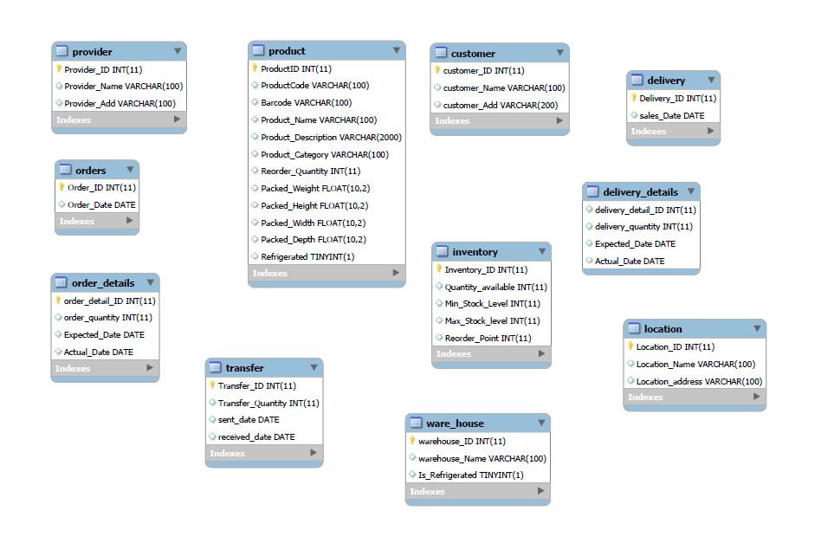

1. We can see that there is no connection created in the ER diagram, later using the one-many connectors in the ER, we created the following connection. For example, connect the Product table to the Inventory table using the Inventory_ID column.

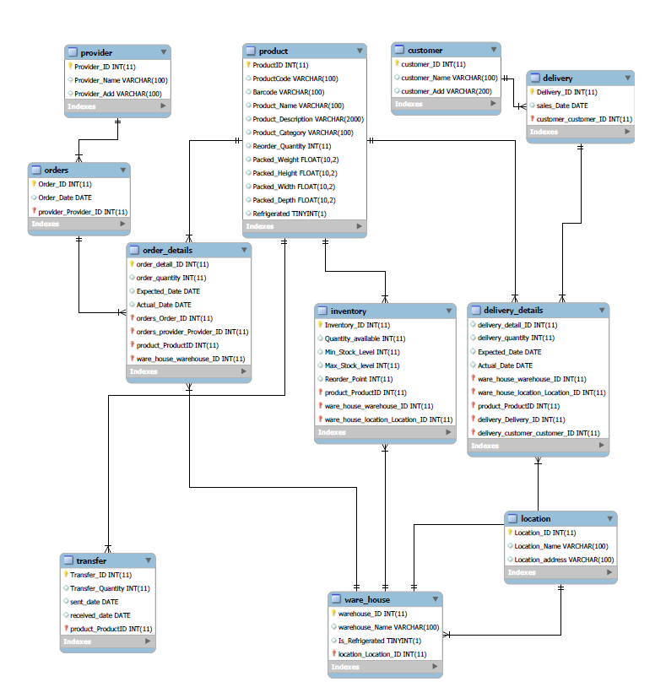

1. After using the forward engineering function, we have created new database called **Inventory_Management_System2,** where this database consists tables with their respective connection with other tables using foreign key.

**Conclusion:**

* The creation of an Inventory Management System (IMS) using SQL involves meticulous table design and connection establishment.
* Reverse engineering and ER diagrams are instrumental in visualizing table relationships and ensuring data coherence.
* Forward engineering generates a cohesive database structure, enabling efficient inventory tracking and streamlined operations.
* SQL's capabilities facilitate effective inventory management, resource optimization, and data-driven decision-making.
* IMS implementation enhances organizational productivity and customer satisfaction in today's competitive business environment.